Figure 2- Prognostic performance of CURB-65 assessed by the area under the receiver operating characteristic curve (AUC) in a subgroup of 3425 participants in which data about oxygen saturation was available.
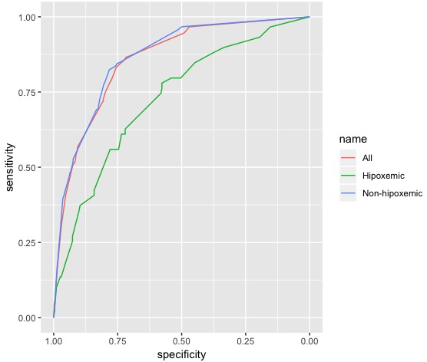

Hypoxemia at admission was defined as present when the oxygen saturation measured by pulse oximetry (SpO2) was less then 90. The area under the receiver operating characteristic curves for CURB-65 is 72.68(65.54-79.83) for hypoxemic, 86.42(82.97-89.88) for non-hypoxemic and 85.74(82.92-88.57) for all participants admitted and non-admitted, respectively.

